Name
Institution of affiliation
Professor
Date
Communication and Speech
The best way I can reduce my anxiety when presenting a speech in this class is to
(S) Always get prepared before I make a presentation.
(E) The surety of the content I present will give me the confidence to speak it out without doubt and fear of contradiction. The major importance of a presentation is the content one delivers. A good mastery of this content therefore from the outline to the theme and to the call to action will make a presentation successful.
(E). For example when i am expected to speak about effective communication, then i will study both verbal and non-verbal cues as well as have examples for illustration. As clearly put in the text “the best, most consistent and direct way to minimize the level of nervousness you feel is through effective preparation” (Mulgrave et al, 5).
(I) in the image below, it is evident that preparation gives one confidence as it enables them to know his/her message, frames it in the best way possible and further refines it to the best so that by the time the presentation is getting to the audience, it is perfect.
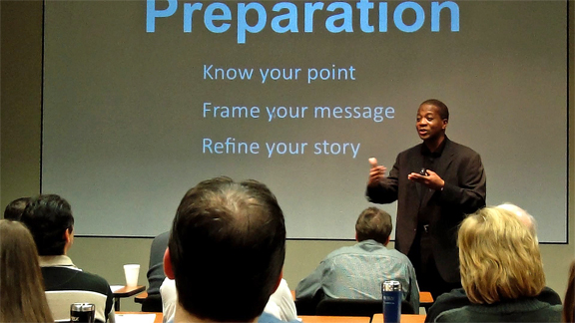
(S) I will consider my pronunciation for me to inflect my voice well and maintain eye contact clearly.
(E) My pronunciation should be very clear and well-coordinated with my pitch, eye contact, and inflection. This is important as it will help me observe the reactions of the audience and gauge their understanding of my presentation.
(E) For example, the inflection will also ensure that my message is delivered with the intended melody coupled with the appropriate pronunciation. The quality of my voice will also help a big way of reducing my anxiety as I will know when to pause and when not to. With a well-maintained tempo, I will be confident that my audience is receiving the right message, as i observe eye contact with them every time I am pronouncing words. As the text puts that" An audience must feel interested in the speaker, and know the speaker cares about them." (Schreiber, Lisa & Morgan 9). Similarly, eye contact will ensure a clear projection of my voice to prevent the audience from losing concentration and interrupting the session. This smoothness will increase my confidence.
(I) it is clear from the image below that eye contact together with the correct inflection, proper pronunciations and the voice quality give the speaker confidence.
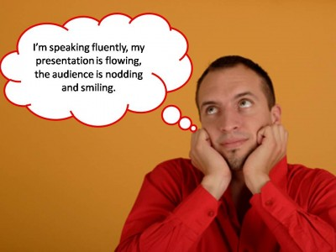

Works Cited
Mulgrave, Dorothy Irene, Wilbur Gilman, and Wilbert Pronovost. Speech: A handbook of voice training, diction, and public speaking. Barnes & Noble, 1954.
Schreiber, Lisa, and Morgan Hartranft. "Introduction to public speaking." The Public Speaking Project (2013).

